Specialist palliative care needs are projected to grow by over 40% in the next 2 decades. We have considered how our systems can manage this, whilst continuing to provide compassionate, excellent care to our patients.

The Rapid Intervention for Palliative and End of Life Care (RIPEL) project was created as a response to critical gaps in the provision and co-ordination of community-based services. It has been set up to enhance the quality of care for patients with a life limiting condition in Oxfordshire and South Northamptonshire through:

- Offering personalised care to more people in their own homes when they are dying, if this is their choice, through integrated and enhanced palliative care and support.
- Reducing the length of time in hospital, so people can continue to be cared for at home with the right support in place in the last 12 months of life and have a better care experience.
- Early supported discharge from hospital, where this is the choice of patients and their families.
- Complementing existing services provided by a wide range of valued hospices and care providers (rather than replacing them).
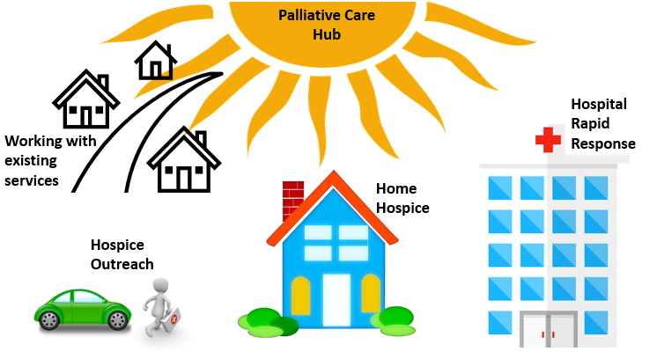
The RIPEL Project is a unique partnership between:
- Oxford University Hospitals (OUH)
- Sobell House Hospice Charity
- Macmillan Cancer Support
- Social Finance.

The project is to run from April 2022 to May 2025 to test our hypothesis that these services are worthwhile.

The RIPEL Project includes 4 interlinked services for adults with advanced life limiting illness who live in catchment, or who receive care from OUH:
Figure 1 The 4 interlinked services of RIPEL working with existing services

- Home Hospice [HH] (launched April 2022)
  - This service supports people in the last two weeks of their life whose choice is to die at home.
  - Patient Support Workers provide domiciliary care and support in the patient’s home with specialist oversight and input from OUH Palliative Care teams.
  - It is run as a virtual ward.
  - Support is also provided for patients known to the palliative care team whilst in crisis, to enable them to stay safely at home.
  - Service hours are 8am to 10pm 7 days a week.

- Hospital Rapid Response [HRR] (launched October 2022)
- This extends the existing OUH Hospital Palliative Care Team to support rapid discharge from hospital for patients who are likely in the last few weeks of life, where going home is the choice for them and their families.
- Service hours are 8am to 6pm 7 days a week.

- Palliative Care Hub [Hub] (launched July 2023)
- Patients already within palliative care and their carers can call the hub directly for advice.
- Through RIPEL, we have remodelled and expanded our telephone access to enable quicker contact with the right professional in a timely manner, with rapid support from the wider MDT as needed.
- Referrals are also made using EPR by OUH staff (for palliative care patients in our hospitals) and via ERS by a wide range of other professionals (for palliative care patients in the community)
- Service hours are 9am to 5pm 7 days a week.

- Hospice Outreach [HO] (launched March 2024)
- An extension of the existing OUH Community Palliative Care Team to support unstable or complex dying palliative care patients in their own homes.
- It is run as a virtual ward or ‘virtual hospice’.
- The aim is to avoid unnecessary admission to hospital for a person who has a palliative care crisis at home (or, if admission to hospital is necessary, making this planned to the appropriate unit rather than an emergency).
- Referrals expanded to urgent care partners (Urgent Community Response, Acute Hospital at Home, Single Point of Access, Oncology Triage, GPs) or community health care professionals already involved with a patient who deteriorates rapidly.
- Service hours 9am to 5pm 7 days a week.

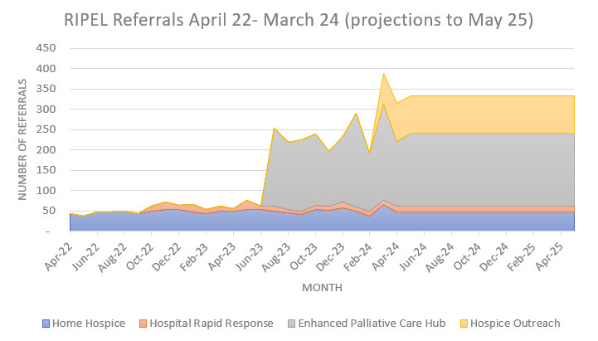
RIPEL Project achievements (April 2022 - April 2024)
- 64.30/73.35 WTE Staff employed.
- 3,104 referrals accepted (Figure 2).
- 11,729 days spent at home instead of in hospital in their last year of life (average 9.03 per patient). Valued at £4.27 million.
- 29 Key Performance Indicators scrutinised via a PowerBI dashboard to ensure services meet quality requirements (waiting times etc.).
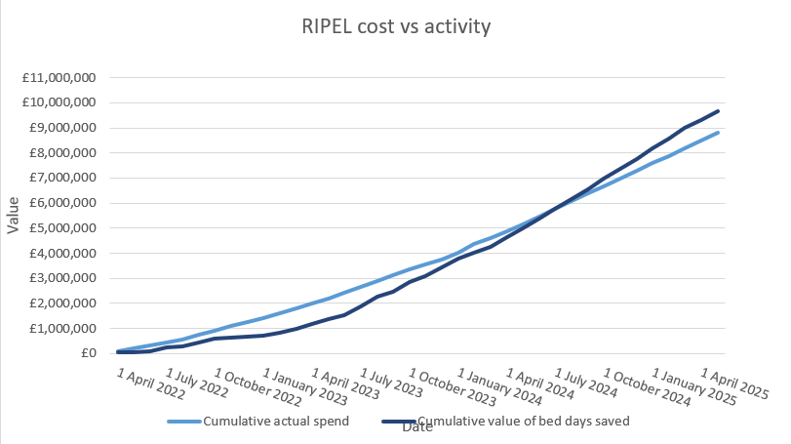
- RIPEL virtual wards are contributing 76.8 (22%) of the virtual ward beds intended for Oxfordshire.
Figure 2 Distribution of referral to RIPEL services April 2022-March 2024

The value of hospital bed days saved are projected to exceed cost of running service (Figure 3).
Assessment of financial viability is an inherent measure to ensure we are spending public money sensibly. Feedback from patients, families, carers and staff is perhaps even more valuable:
“Every member of the team showed tremendous care and humanity for them, which I and the rest of the family will always be thankful for”
“They were so kind, respectful, gentle, almost loving”
Figure 3 Value of saved hospital beds vs cost of RIPEL services April 2022-May 2025
- 38/41 (93%) feedback postcards received rated Home Hospice as ‘very good’
“Her death had been perfect and all she had
hoped for”

- Finalist for HSJ Patient Safety Awards 2023
- Finalists for OUH Staff Recognition Awards 2023 and 2024
- Finalists in 4 categories for Palliative Care Awards 2024
Evaluations
- Patient and Carer Feedback
  - 100 feedback postcards were distributed to households who used Home Hospice.
  - Compliments and complaints, informal and formal, continue to be logged and acted upon.
  - A questionnaire which incorporates national ‘Friends and Family Test’ questions will be distributed to all households who have consented from May 2024.

- Palliative Care Hub Service Hours
  - We investigated the need to expand Palliative Care Hub hours beyond 5pm. A pilot took place over 6 weeks from Feb-March 2024 whereby a member of hub clinical staff accompanied the Single Point of Access (SPA) team between 5 and 8pm on weekdays. SPA is the most likely referral route for acute palliative care needs and a reasonable proxy of community needs. During the 27 shifts covered, advice was sought on only 5 occasions, all of which were either non-urgent (could have waited until following day) or had alternative advice routes already available (authorisation of admission to hospice must go through on-call medical staff as standard already).
  - In conclusion, extending RIPEL Enhanced Palliative Care Hub hours beyond 9am to 5pm has not been justified. This case was presented to the RIPEL Steering Group in April 2024 who support the decision to not extend hours, with staffing plans to be revised appropriately.

- Equality, Diversity, and Inclusion (EDI)
  - The Palliative Care EDI Project Officer has chosen RIPEL as a use case to assess and improve our EDI reach into our communities across Oxfordshire and South Northamptonshire.
  - Investigations in 2023 noted that up to 35% of ethnicity data each month was missing for patients using Home Hospice, inhibiting the reliability of mapping this cohort onto the background population. By working with frontline teams, we were able to find ways to include ethnicity simply and reliably in workflows. Our data is now >90% complete (100% is not expected as patients have the right not to state their ethnicity). We are now in a stronger position to map our data on ethnicity and further characteristics to our catchment to identify areas of unmet need, or confidently celebrate the diversity of those accessing our services. Work is ongoing to complete mapping with the 2022 data set.
  - Virtual wards and developments of care available in one’s home have prompted investigations with our hospital teams to ensure being at home at the end of life is an option appropriately explored without bias. Our teams are in conversation with the learning and disabilities teams at OUH to audit end of life choices for this cohort, directing further education if found necessary.

- Home Hospice Toolkit
  - We have assessed our Home Hospice service against the standards proposed in the Hospice UK toolkit. While the service scored high in all key areas (Skills and Ethos of care providers, Support directed at Carers, Sustainability, Volunteers, Integration and Coordination, Marketing and Referral), it was identified that improvements could be made in the areas of ‘support directed at carers’, ‘Marketing & Referral’ and ‘Sustainability’.
    - Sustainability is already being addressed by the business case.
    - A research project is currently looking at unpaid carers of Home Hospice Patients, the outcome of which may inform how we can further support carers.
  - The recommendations in the toolkit are being reviewed and suitable solutions will be adopted in consultation with our key partners.

- Home Hospice impact on carers
  - A colleague is working towards a PhD on the impact of Home Hospice on carer experiences. Initial development has been successful, and questionnaires are now actively being distributed to eligible persons.

- Hospital Rapid Response Unmet need
  - We noted that referrals accepted into to our HRR service were significantly lower than originally forecast. This prompted investigation into whether we are not reaching everyone we could have helped. An audit took place to assess experiences of patients who may have been eligible but not referred in Oct 2023. This only identified 3 eligible patients who were not referred for HRR. This audit is extended over additional months to further interrogate and understand the data and will be developed as a final honours paper for an Oxford University Medical Student.
  - A deeper dive is underway into reasons referrals transpired to not be suitable for HRR.

- Transport
  - The importance of transport needs in palliative care has been recognised by transport partners, shown by their explicit incorporation of palliative care patients in their operating procedures.
  - Despite this, transport remains a source of stress and delays to patient pathways for RIPEL patients as well as those in the wider palliative care service. We have collated formal and informal complaints related to transport from Feb 2023-Feb 2024, assessed transport use and documented this in a paper to take to senior management and charity partners to justify our proposal to pilot dedicated palliative transport services in 2024 which Sobell House Hospice Charity have agreed to fund.

- Carbon Footprint
  - We have linked in with OUH and national sustainability leads to see how to best assess the carbon footprint of RIPEL services. National data suggests that virtual wards have a lighter footprint than in-patient equivalents and we would like to assess this locally, particularly given the significant non-pay costs due to transport between patients of the Home Hospice Care Team. Data capture is underway.
  - The carbon footprint of anticipatory medicines is to be investigated compared to in-patient stock.

- Co-morbidities
  - Diagnosis is captured as part of RIPEL monthly KPIs. We would like to utilise national tools to assess further the co-morbidities profile of our patients. The method for this has been proposed using the Cambridge co-morbidity score though is yet to be applied.

- Pharmacy
  - Gaps in desired pharmacy provision have been highlighted as a risk to Hospice Outreach standards. Options around this have been documented and are being investigated further.

- Palliative Care Outcome Measures
  - Our palliative care outcome measures data has been developed so that it can be visualised using the national PCOM360 tool. We are working with RIPEL partners to best use this to maximise the standards offered by each service, not just within RIPEL but across OUH Palliative Care.
Next Steps
- Finalise business case to bid for ongoing financial support of RIPEL from June 2025.
- Conclude projects outlined above.
- Enhance links with referrers including 111, Acute General Medicine and Emergency Departments.
- Continue to develop a Patient Participation, Involvement and Experiences (PPIE) group for Palliative Care and utilise this for feedback and ongoing co-design of services.
- Further assess staff experiences around RIPEL.
- Establish methods to capture documentation of Advance Care Plans.
- Work with external partners interested in researching RIPEL further.

If you would like any further information, please contact PallCareLeadNurse@ouh.nhs.uk

